

INTRODUCTION TO COMPUTER SYSTEMS (IT1020)

Year 1, Semester 1

Worksheet 03 Submission

22278944, Vikum Chathuranga Basnayaka

Y1.S1.WD.IT.17

13 – 11 - 2022

**Activity (2)**

a).

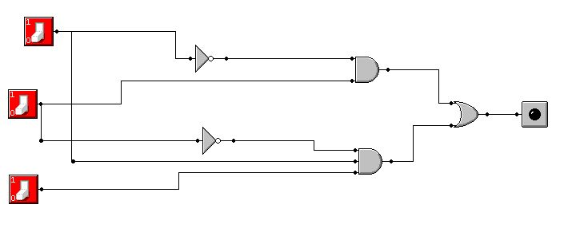

b).

|  |  |  |  |  |  |  |  |
| --- | --- | --- | --- | --- | --- | --- | --- |
| X | Y | Z | Y’ | Z’ | Y’Z | XYZ’ | F = Y’Z+XYZ’ |
| 0 | 0 | 0 | 1 | 1 | 0 | 0 | 0 |
| 0 | 0 | 1 | 1 | 0 | 1 | 0 | 1 |
| 0 | 1 | 0 | 0 | 1 | 0 | 0 | 0 |
| 0 | 1 | 1 | 0 | 0 | 0 | 0 | 0 |
| 1 | 0 | 0 | 1 | 1 | 0 | 0 | 0 |
| 1 | 0 | 1 | 1 | 0 | 1 | 0 | 1 |
| 1 | 1 | 0 | 0 | 1 | 0 | 1 | 1 |
| 1 | 1 | 1 | 0 | 0 | 0 | 0 | 0 |

**Activity (3)**

a).

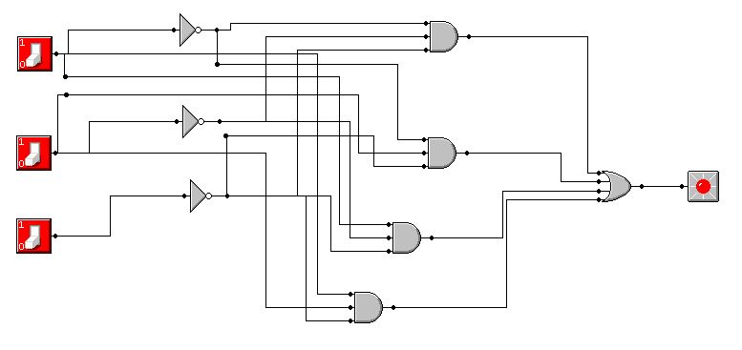

b).

F =A’B’C’+A’BC’+AB’C’+ABC’

|  |  |  |  |  |  |  |  |  |  |  |  |
| --- | --- | --- | --- | --- | --- | --- | --- | --- | --- | --- | --- |
| *A* | *B* | *C* | *A’* | *B’* | *C’* | *A’B’C’* | *A’BC’* | *AB’C’* | *ABC’* | *F* | *SoP* |
| 0 | 0 | 0 | 1 | 1 | 1 | 1 | 0 | 0 | 0 | 1 | A’B’C’ |
| 0 | 0 | 1 | 1 | 1 | 0 | 0 | 0 | 0 | 0 | 0 |  |
| 0 | 1 | 0 | 1 | 0 | 1 | 0 | 1 | 0 | 0 | 1 | A’BC’ |
| 0 | 1 | 1 | 1 | 0 | 0 | 0 | 0 | 0 | 0 | 0 |  |
| 1 | 0 | 0 | 0 | 1 | 1 | 0 | 0 | 1 | 0 | 1 | AB’C’ |
| 1 | 0 | 1 | 0 | 1 | 0 | 0 | 0 | 0 | 0 | 0 |  |
| 1 | 1 | 0 | 0 | 0 | 1 | 0 | 0 | 0 | 1 | 1 | ABC’ |
| 1 | 1 | 1 | 0 | 0 | 0 | 0 | 0 | 0 | 0 | 0 |  |

c).

SoP = A’B’C’ + A’BC’ + AB’C’ + ABC’

F = A’B’C’+ A’BC’+ AB’C’+ ABC’

= A’ (B’C’ + BC’) + AB’C’+ ABC’ (By distributive law)

= A’ (B’C’ + BC’) + C’ (AB’ + AB) (By distributive law)

= A’C’ (B’ + B) + C’ (AB’ + AB) (By distributive law)

= A’C’ .1 + C’ (AB’ + AB) (By inverse law)

= A’C’ + C’ (AB’ + AB) (By identity law)

= A’C’ + AC’ (B’ + B) (By distributive law)

= A’C’ + AC’.1 (By inverse law)

= A’C’ + AC’ (By identity law)

= C’ (A’ + A) (By distributive law)

= C’ (By inverse law)

d).

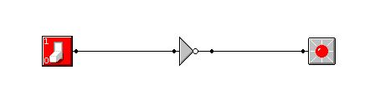

C’

C

**Activity (4)**

a).

|  |  |  |  |  |
| --- | --- | --- | --- | --- |
| In Dec | A | B | C | Output  F = (A+B+C) |
| 0 | 0 | 0 | 0 | 0 |
| 1 | 0 | 0 | 1 | 0 |
| 2 | 0 | 1 | 0 | 1 |
| 3 | 0 | 1 | 1 | 1 |
| 4 | 1 | 0 | 0 | 0 |
| 5 | 1 | 0 | 1 | 1 |
| 6 | 1 | 1 | 0 | 0 |
| 7 | 1 | 1 | 1 | 1 |

* SoP = A’BC’ + A’BC + AB’C + ABC = F

b).

F = A’BC’ + A’BC + AB’C + ABC

c).

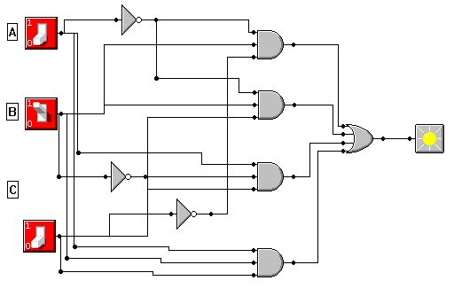

d).

F = A’BC’ + A’BC + AB’C + ABC

= A’ (BC’ + BC) + AB’C + ABC (By distributive law)

= A’B (C’ + C) + AB’C + ABC (By distributive law)

= A’B. 1 + AB’C + ABC (By inverse law)

= AB’ + AB’C + ABC (By identity law)

= AB’ + A (B’C + BC) (By distributive law)

= AB’ + AC (B’ + B) (By distributive law)

= AB’ + AC. 1 (By inverse law)

= AB’ + AC (By identity law)

= A (B’ + C) (By distributive law)

e)/ f).

